210905212 LAB – 6
1)
SEPMAP.PY:
import sys

def read_input(file):
for line in file:
yield line.split()

def main(separator='\t'):
data = read_input(sys.stdin)
for words in data:
for word in words:
print('%s%s%d' % (word, separator, 1))
if __name__=="__main__":
main()
SEPRED.PY:
from itertools import groupby
from operator import itemgetter
import sys

def read_mapper_output(file, separator='\t'):
for line in file:
yield line.rstrip().split(separator, 1)

def main(separator='\t'):
data = read_mapper_output(sys.stdin, separator=separator)
for current_word, group in groupby(data, itemgetter(0)):
try:
total_count = sum(int(count) for current_word, count in group)
print ("%s%s%d" % (current_word, separator, total_count))
except ValueError:
pass
if __name__=="__main__":
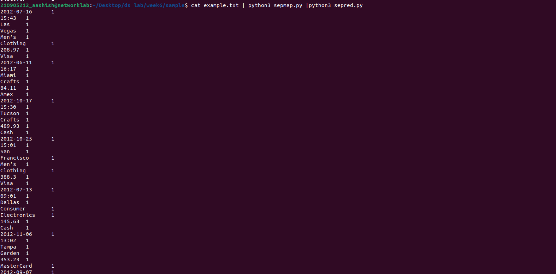
main()
q2)
item map:
#for example.txt
q2)
item map:
import fileinput
for line in fileinput.input():
data = line.strip().split("\t")
if len(data)==6:
date, time, location, item, cost, payment = data
print("{0}\t{1}".format(location, cost))

#for heart_disease_data.csv
import fileinput
for line in fileinput.input():
data = line.strip().split(",")
if len(data) == 14:
age, sex, cp, trestbps, chol, fbs, restecg, thalach,exang, oldpeak, slope, ca, thal, target = data
print ("{0}\t{1}".format(age, chol))
item red:

#for example.txt
import fileinput
max_value = 0
old_key = None
for line in fileinput.input():
data = line.strip().split("\t")
if len(data) != 2:
continue
current_key, current_value = data
if old_key and old_key != current_key:
print(old_key,"\t", max_value)
max_value = 0
if float(current_value) > float(max_value):
max_value = float(current_value)
old_key = current_key
if old_key != None:
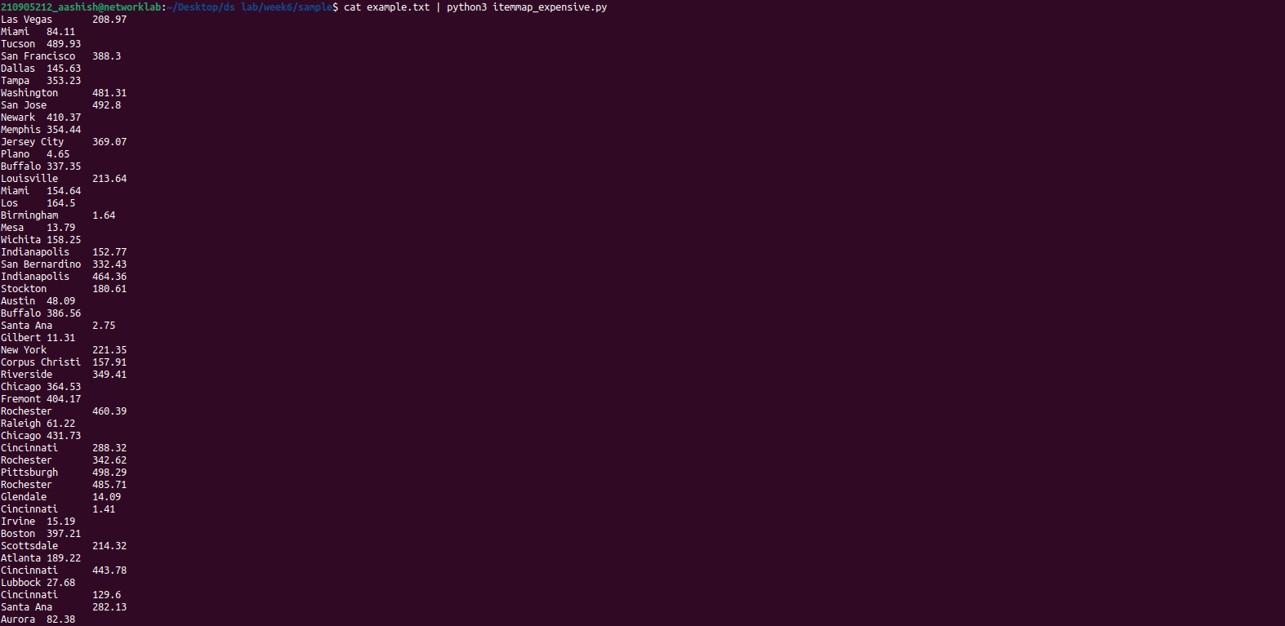
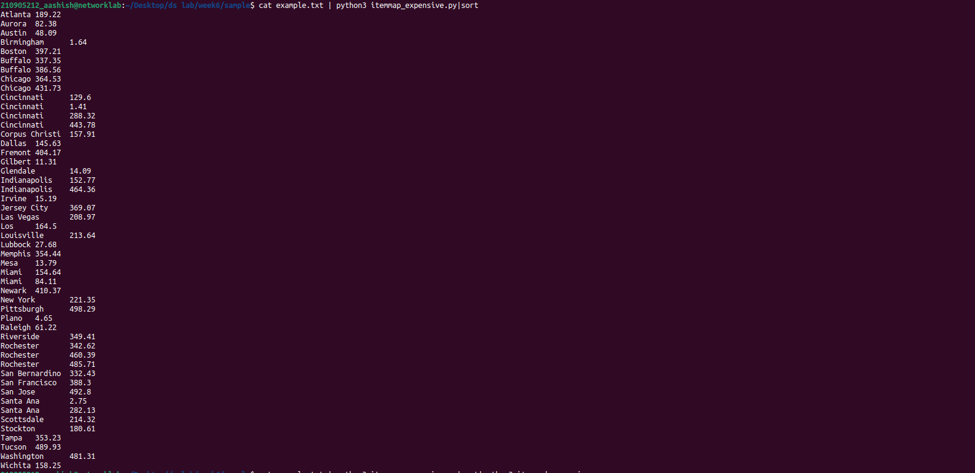
print (old_key, "\t", max_value)
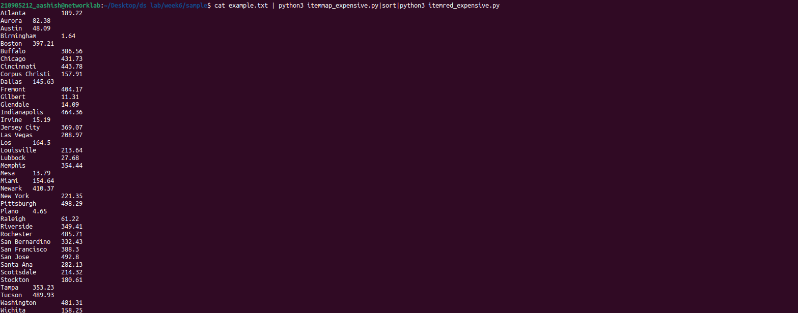
q3)

